Chapter 7

Section 7.1
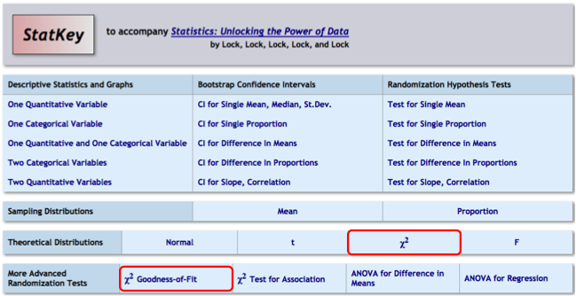
First go to the chi-square Goodness of Fit page to get the chi-square test statistic. Note the value provided directly under Original Sample.
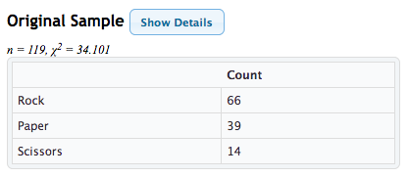
Click on the Show Details button to bring up a table of Observed and Expected counts, and Contributions to chi-square.
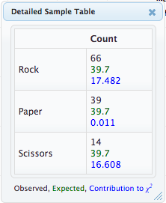

Suppose you didn’t have the data file to upload here, but instead had just been given the summary numbers. Here’s how you would enter them in the “Edit Data” button.
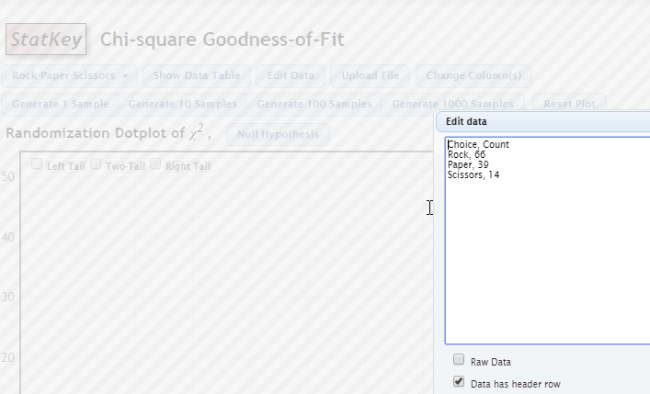

Next, go to the chi-square theoretical distribution to get a p-value. Follow the instructions for Normal distributions in chapter 5 for basic mechanics, but of course always choose Right Tail with this distribution.

Although a randomization distribution is also possible here, we tend to emphasize the theoretic distributions more at this stage in the course. You do not need to generate any samples on the Chi-square Goodness of Fit page to get the information you need.

Section 7.2
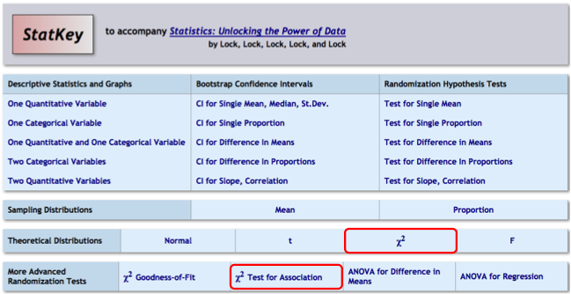
Follow all of the instructions for section 7.1, except use the chi-square test for Association instead of the chi-square test of Goodness of Fit.

If you hadn’t been given the data file, but instead just had a two-way table of values, you would enter the information from the table WITHOUT the Totals. There is a very precise way you need to enter it. You can see that way from any of the datasets already available here. Pick one of them and compare what you see in the two-way table on the right and in the Edit Data box.
sc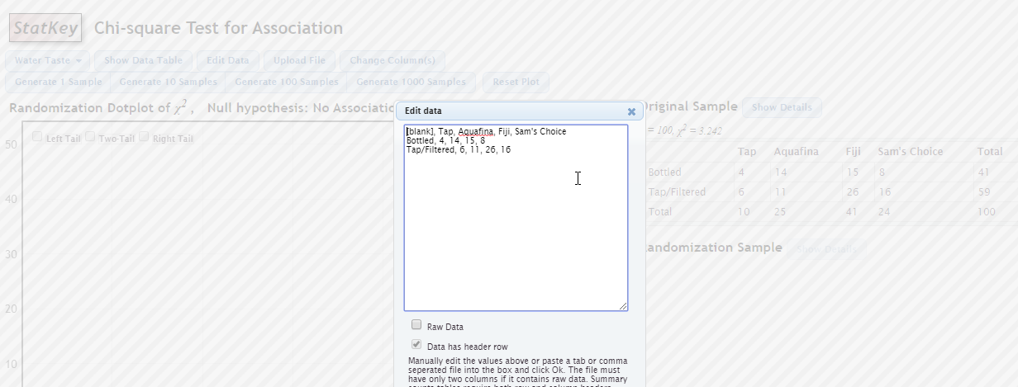

I recommend that you type in your new table just below the one that is already showing, following the format carefully, and, after you are sure you followed the format, then delete the one that was already showing, moving what you typed up to the top of the box.

